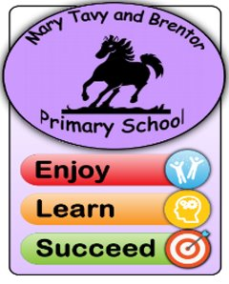
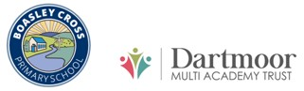
Modern Foreign Languages – Curriculum Statement
“The limits of my language are the limits of my world” Ludwig Wittgenstein (philosopher)

Curriculum Intent
The intention of the French curriculum at Mary Tavy and Brentor Primary School and Dartmoor Multi Academy Trust, above everything, is to ensure children develop a love of learning languages which will result in resilient linguists. Our pupils understand the importance of language learning and develop a deep empathy for those who are learning English as an additional language.

Our curriculum extends pupils’ cultural capital and deepens pupils’ understanding of the world. Pupils learn about France and the Francophone world and its customs, traditions, and history. Pupils are confident in engaging with French songs, stories and films starting from KS1. This intercultural knowledge develops empathy with other cultures and equips pupils for future international lives.

Through our curriculum, pupils are well prepared for Key Stage 3 language learning. Pupils absorb patterns of language through continuous practice, retrieval, and interleaving, which can be manipulated to talk about themselves and others in a variety of contexts over time. Pupils acquire a range of strategies for language learning and knowledge of language. We do not know which languages our pupils may need in the future, but we understand the skills they will need to approach language learning in later life. For that reason, we have exposed the children to learning Japanese and German, as well as now introducing French as the main language studied.

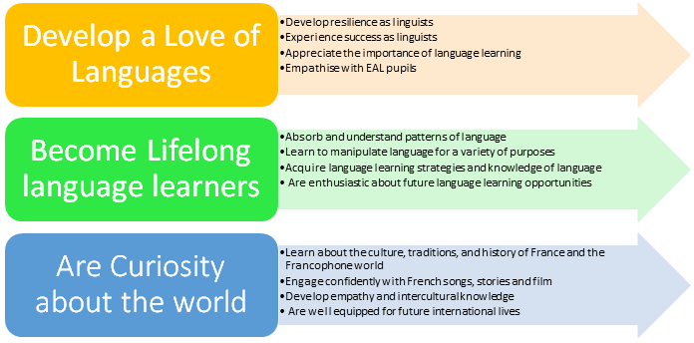

Implementation
Pupils receive two 30-minute lessons of French a week; 30 minute session led by a specialist teacher or the MFL lead and the other follow up 30-minute session will be led by the class teacher. Teachers also incorporate French into their regular classroom routines, using French countdowns and instructions.

Our approach ensures pupils are confident language learners. New language is carefully scaffolded, and support is only removed once language is acquired to ensure high success rates. Activities and resources are adapted and developed so that all pupils, including those with SEND, can feel a sense of achievement. Our pupils absorb key structures, through extensive practice, repetition, retrieval and interleaving, which over time ensures language can be adapted for all topics and enables pupils use language spontaneously.

Language is introduced through knowledge organisers; ensuring pupils can communicate accurately in full sentences. Once pupils have leant these sentences off by heart, they examine the grammar. Understanding how languages are structured empowers pupils to learn new languages in the future, as well as enabling pupils to manipulate language to create their own sentences in French.

New language is modelled through listening activities. Pupils then undertake a variety of reading tasks before moving onto speaking and writing tasks. We prioritise activities that lead to pupils using language spontaneously; pupils practise recognising and responding to language at speed.

Phonics are taught implicitly through our modelling and feedback on speaking tasks. We also teach phonics explicitly and ensure key phonemes are carefully sequenced and revisited which in time, leads to pupils having the confidence to read out loud independently in French. Use of French songs, rhymes, stories or films each term enables pupils to gain confidence with their pronunciation and intonation, as well as gain cultural information.
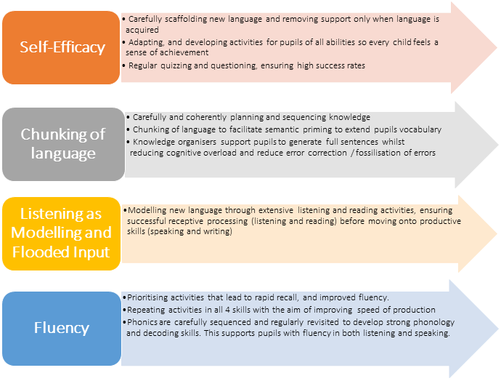

Impact

As a result of our curriculum, we have a community of enthusiastic, tolerant, and curious linguists who enjoy showcasing their developing knowledge and skills. Pupils communicate in French with each other and their teacher within and outside of dedicated French lessons, such as the register routine, and basic classroom instructions. Pupils understand that every language has a structure and appreciate the differences and similarities with English. Pupils are well prepared for language learning in later life as well as KS3, whether that be French or another language.

French Curriculum Progression

Key Stage One
In 2022-23 EYFS and KS1 will be introduced to a French song each half term. These songs have been aligned with our KS2 curriculum. Teachers may want to use the older children to model the songs in class or use singing assemblies to introduce the songs to all pupils. EYFS and KS1 staff may want to select a different French song from the list of core songs to match their current topic or focus. All songs will be revisited in KS2, where pupils will complete more demanding activities related to phonics or grammar or spelling.

Key Stage Two
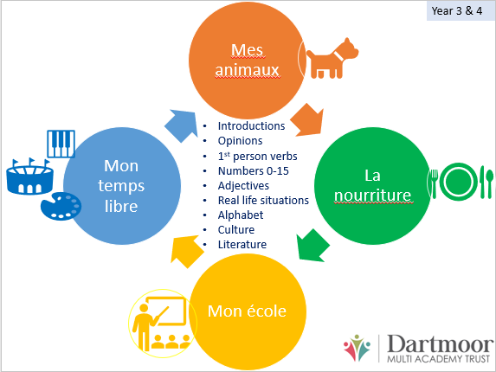
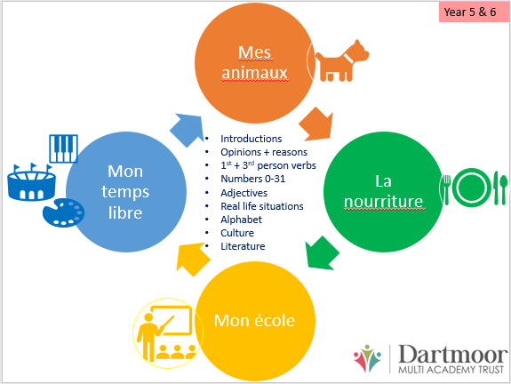
There is a four-year rolling programme, and each year has a different context. In 2021-22 our context was animals and in 2022-23 our context will be food. Language is extended in Years 5 and 6 to build on structures and knowledge gained in Years 3 and 4.

